BANK LOAN APPLICATION
- Bank Loan Report | Summary
KPI’S:
Total Bank Loan Application
SELECT COUNT (id) AS Total_Loan_Appication FROM Loan_Sql_data
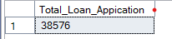

MTD
SELECT COUNT (id) AS MTD_Total_Loan_Application FROM Loan_Sql_data
WHERE MONTH (issue_date) =12 AND YEAR(issue_date)=2021
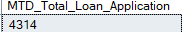

PMTD
SELECT COUNT (id) AS PMTD_Total_Loan_Application FROM Loan_Sql_data
WHERE MONTH(issue_date)=11 AND YEAR(issue_date)=2021
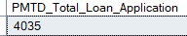

Total Funded Amount
SELECT SUM(loan_amount) AS Total_Funded_Amount FROM Loan_Sql_data
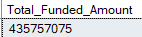

MTD Total_ Funded Amount
SELECT SUM(loan_amount) AS MTD_Total_Funded_Amount FROM Loan_Sql_data
WHERE MONTH(issue_date)=12 AND YEAR(issue_date)=2021
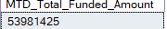
PMTD Total Payment Received
SELECT SUM(loan_amount) AS PMTD_Total_Funded_Amount FROM Loan_Sql_data
WHERE MONTH(issue_date)=11 AND YEAR(issue_date)=2021
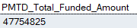

Total Payment Received
SELECT SUM(total_payment) AS Total_Payment_Received FROM Loan_Sql_data
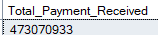

MTD Total Payment Received
SELECT SUM(total_payment) AS MTD_Total_Payment_Received FROM Loan_Sql_data
WHERE MONTH(issue_date)=12 AND YEAR(issue_date)=2021
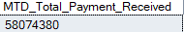

PMTD Total Payment Received
SELECT SUM(total_payment) AS PMTD_Total_Payment_Received FROM Loan_Sql_data
WHERE MONTH(issue_date)=11 AND YEAR(issue_date)=2021
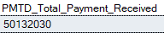

Total Interest
SELECT ROUND(AVG(int_rate),4)*100 AS Total_Interest FROM Loan_Sql_data
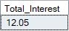

MTD Total Interest
SELECT ROUND(AVG(int_rate),4)*100 AS MTD_Total_Interest FROM Loan_Sql_data
WHERE MONTH(issue_date)=12 AND YEAR(issue_date)=2021
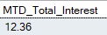

PMTD Total Interest
SELECT ROUND(AVG(int_rate),4)*100 AS MTD_Total_Interest FROM Loan_Sql_data
WHERE MONTH(issue_date)=11 AND YEAR(issue_date)=2021
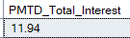

DTI
SELECT ROUND(AVG(dti),4)*100 Avg_DTI FROM Loan_Sql_data
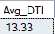

MTD Avg DTI
SELECT ROUND(AVG(dti),4)*100 Avg_DTI FROM Loan_Sql_data
WHERE MONTH(issue_date)=12 AND YEAR(issue_date)=2021
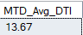

PMTD Avg DTI
SELECT ROUND(AVG(dti),4)*100 Avg_DTI FROM Loan_Sql_data
WHERE MONTH(issue_date)=11 AND YEAR(issue_date)=2021
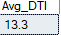

Good Loan Percentage
SELECT
(COUNT(CASE WHEN loan_status='Fully Paid' OR loan_status='Current' THEN id END)*100)
/COUNT(id) AS Good_Loan_Percentage
FROM Loan_Sql_data
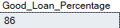

Good Loan Application
SELECT COUNT(id) AS Good_Loan_Application FROM Loan_Sql_data
WHERE loan_status='Fully Paid' OR loan_status='Current'
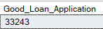

Good Loan Received Amount
SELECT SUM(total_payment) AS Good_Loan_Received_Amount FROM Loan_Sql_data
WHERE loan_status='Fully Paid' OR loan_status='Current'
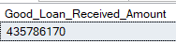
Bad Loan Percentage
SELECT
(COUNT(CASE WHEN loan_status='Charged Off' THEN id END)*100)/
COUNT(id) AS Bad_Loan_Percentage
FROM Loan_Sql_data
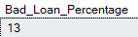
Bad Loan Application
SELECT COUNT(id) AS Bad_Loan_Application FROM Loan_Sql_data
WHERE loan_status='Charged Off'
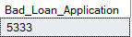
Bad Loan Funded Amount
SELECT SUM(loan_amount) AS Bad_Loan_Funded_Amount FROM Loan_Sql_data
WHERE loan_status='Charged Off'
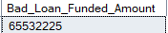

Bad Loan Amount Received
SELECT SUM(total_payment) AS Bad_Loan_Amount_Received FROM Loan_Sql_data
WHERE loan_status='Charged Off'
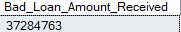

Loan Status
SELECT
loan_status,
COUNT(id) AS Total_Loan_Application,
SUM(total_payment) AS Total_Payment_received,
SUM(loan_amount) AS Total_Funded_Amount,
AVG(int_rate*100) AS Interest_Rate,
AVG(dti*100) AS DTI
FROM Loan_Sql_data
GROUP BY loan_status

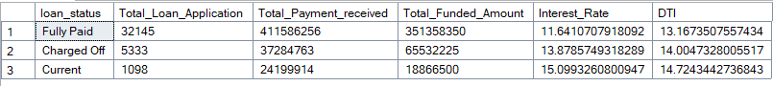

MTD Loan Status
SELECT
loan_status,
SUM(total_payment) AS MTD_Total_Amount_Received,
SUM(loan_amount) AS MTD_Total_Funded_Amount
FROM Loan_Sql_data
WHERE MONTH(issue_date)=12
GROUP BY loan_status
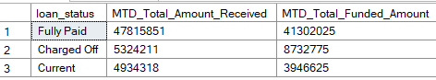

Month Wise
SELECT
MONTH(issue_date)AS MONTH_Number,
DATENAME(MONTH,issue_date) AS Month_Name,
COUNT(id) AS Total_Loan_Application,
SUM(loan_amount) AS Total_Funded_Amount,
SUM(total_payment) AS Total_Amount_Received
FROM Loan_Sql_data
GROUP BY MONTH(issue_date),DATENAME(MONTH,issue_date)
ORDER BY MONTH(issue_date)
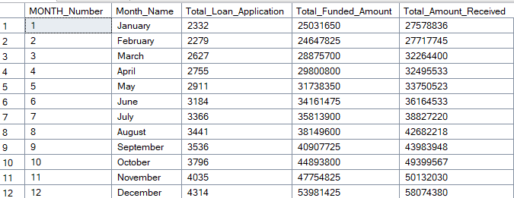

State Wise
SELECT
address_state,
COUNT(id) AS Total_Loan_Application,
SUM(loan_amount) AS Total_Funded_Amount,
SUM(total_payment) AS Total_Amount_Received
FROM Loan_Sql_data
GROUP BY address_state
ORDER BY COUNT(id) DESC
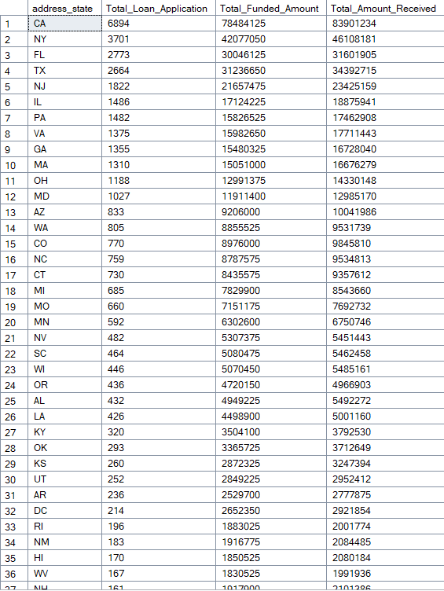

Term Wise
SELECT
term,
COUNT(id) AS Total_Loan_Application,
SUM(loan_amount) AS Total_Funded_Amount,
SUM(total_payment) AS Total_Amount_Received
FROM Loan_Sql_data
GROUP BY term
ORDER BY term
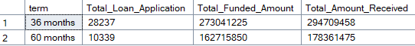

EMP Lenght
SELECT
emp_length,
COUNT(id) AS Total_Loan_Application,
SUM(loan_amount) AS Total_Funded_Amount,
SUM(total_payment) AS Total_Amount_Received
FROM Loan_Sql_data
GROUP BY emp_length
ORDER BY emp_length
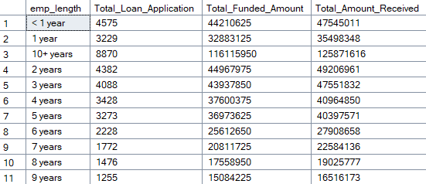

Purpose Wise
SELECT
purpose,
COUNT(id) AS Total_Loan_Application,
SUM(loan_amount) AS Total_Funded_Amount,
SUM(total_payment) AS Total_Amount_Received
FROM Loan_Sql_data
GROUP BY purpose
ORDER BY COUNT(id) DESC

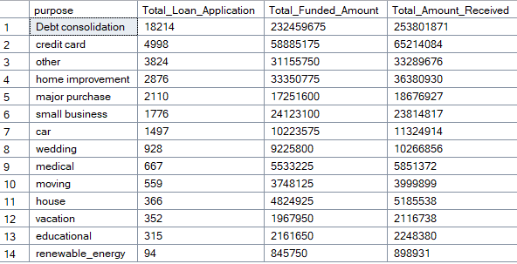

OwnerShip Wise
SELECT
home_ownership,
COUNT(id) AS Total_Loan_Application,
SUM(loan_amount) AS Total_Funded_Amount,
SUM(total_payment) AS Total_Amount_Received
FROM Loan_Sql_data
GROUP BY home_ownership
ORDER BY COUNT(id) DESC
